Adavanced Data Management & Decision Support System

Mobility Data Management System Report

Name: Muhammad Umer Farooq
Matriculation: 922739
Submitted to: Gloria Lopiano & Andrea Campagner

Artificial Intelligence for Science & Technology
University of Milano-Bicocca.

Abstract

This project presents a comprehensive data management system for mobility data using multiple database technologies. The system integrates relational, NoSQL, graph, and big data processing approaches to handle and analyze trip-related data.

PostgreSQL is used for structured relational data storage with normalized tables and constraints. MongoDB is used for flexible document-based storage, supporting nested structures and aggregation queries. Neo4j is used to represent relationships between users, trips, and stations using graph modeling. Python is used to perform CRUD operations on MongoDB, demonstrating application-level interaction. Apache Spark is used for data processing and analytical queries.

The project demonstrates the use of different data management paradigms and highlights their strengths in handling complex data scenarios.

Introduction

Within contemporary analytical software ecosystems, governing and evaluating massive quantities of varied information demands the deployment of varied storage architectures. Conventional structured repositories excel at handling tightly organized records, whereas document-centric and network-based systems offer schema elasticity and superior connectivity mapping. Furthermore, high-performance data processing frameworks are critical for executing extensive analytical workflows.

This initiative centers on building a transit information infrastructure that synthesizes diverse architectural approaches. The environment administrates records concerning consumers, journeys, hubs, and system occurrences. It showcases how tabular, document-oriented, and network-oriented storage solutions can operate in tandem to preserve and evaluate sophisticated information bundles.

PostgreSQL is deployed as the structured framework to house organized records utilizing schema design rules and validation checks. MongoDB is deployed to house semi-organized records structured as JSON-style objects. Neo4j is deployed to map out the connections linking components like consumers, journeys, and hubs. Python is deployed for application-layer communication and data modifications, whereas Apache Spark is deployed for batch processing and complex analytical lookups. The goal of this initiative is to investigate and weigh varied information storage methodologies while showcasing their functional deployment within a practical context.

System Overview and Data Model
The mobility data management system is designed to handle and analyze data related to users, trips, stations, and events. The system integrates multiple database models to efficiently manage structured, semi-structured, and relational data.

Entities Description
The system consists of the following main entities:

Users: Represents individuals who perform trips. Each user has attributes such as name, surname, birthdate, and country.
Stations: Represents locations where trips start and end. Each station includes attributes such as name, city, and capacity.
Trips: Represents the journey performed by users. Each trip is associated with a user and includes start and end stations, timestamps, and cost.
Events: Represents additional information related to trips, such as GPS data, Errors, Delays
and Battery status.

Relationships
The system models the following relationships:

- A user can perform multiple trips.
- Each trip starts at one station and ends at another station.
- Each trip can have multiple associated events.

Data Modeling Approach
Different database technologies are used to represent the data model:

In PostgreSQL, the data is normalized into multiple tables (users, trips, stations, events) with foreign key relationships.
In MongoDB, the data is stored as JSON documents, where user and station details are embedded within trip documents, and events are stored as arrays.
In Neo4j, the data is represented as a graph where users, trips, and stations are nodes connected by relationships such as PERFORMED, STARTS_AT, and ENDS_AT.
This multi-model approach allows efficient data storage, querying, and analysis across different database systems.

PostgreSQL Implementation
PostgreSQL is used in this project as a relational database to store structured mobility data. It ensures data integrity through normalization, primary keys, and foreign key constraints.

Database Design
The relational model consists of the following tables:

Users: Stores user information including name, surname, birthdate, and country.

Stations: Stores station details such as name, city, and capacity.

Trips: Stores trip data and references users and stations through foreign keys.

Events: Stores event-related data linked to trips.

This design follows normalization principles to eliminate redundancy and maintain consistency.

Table Representation

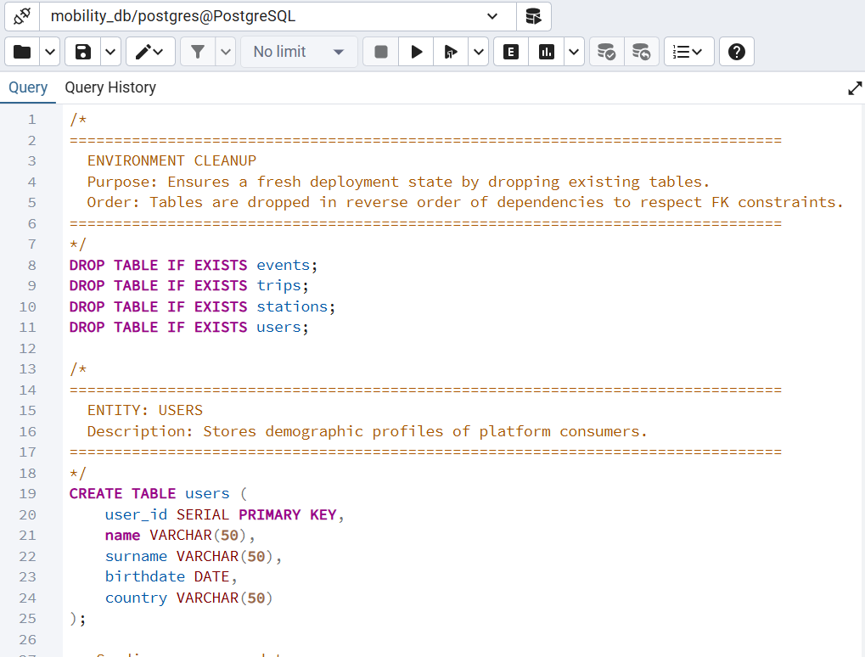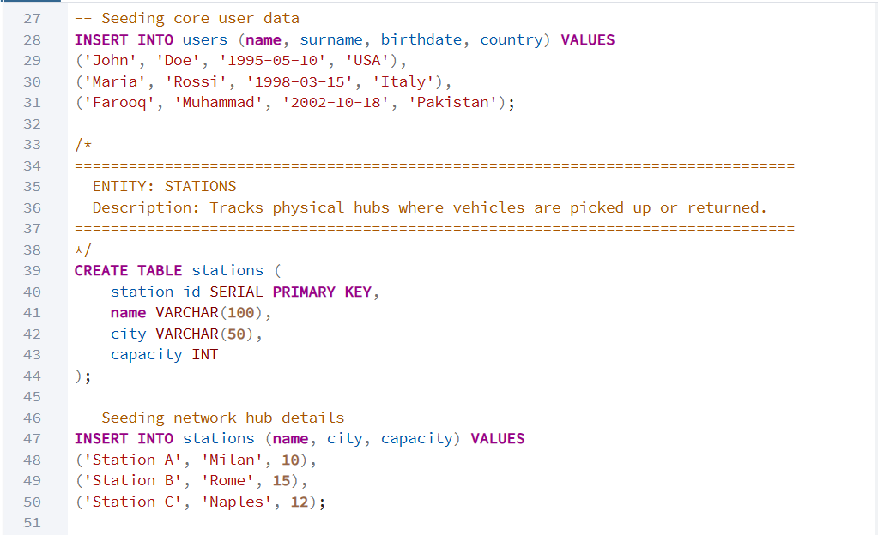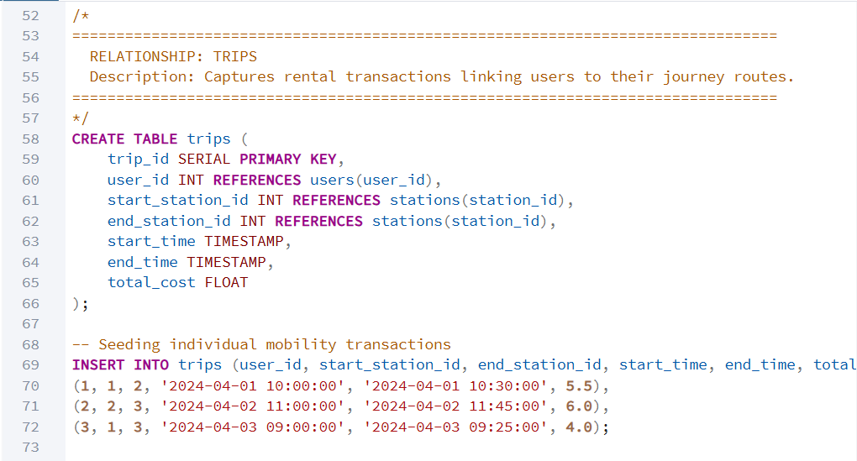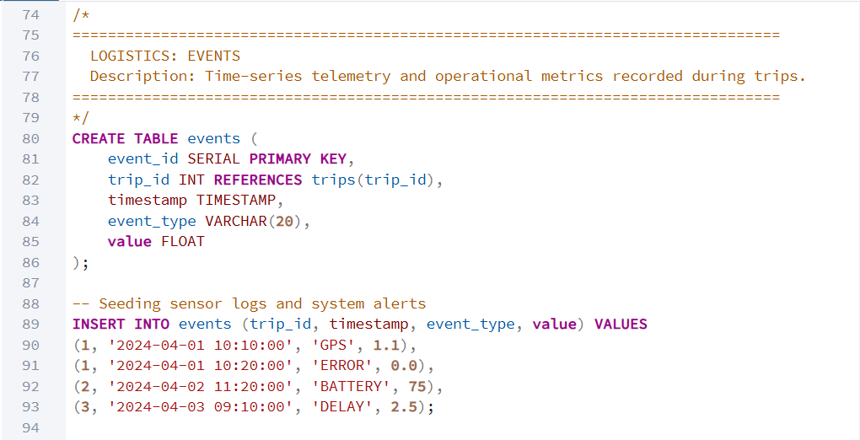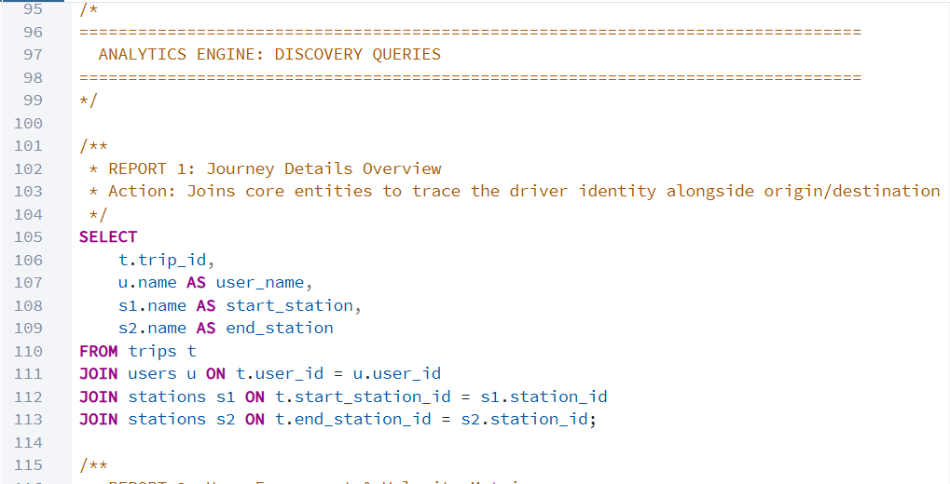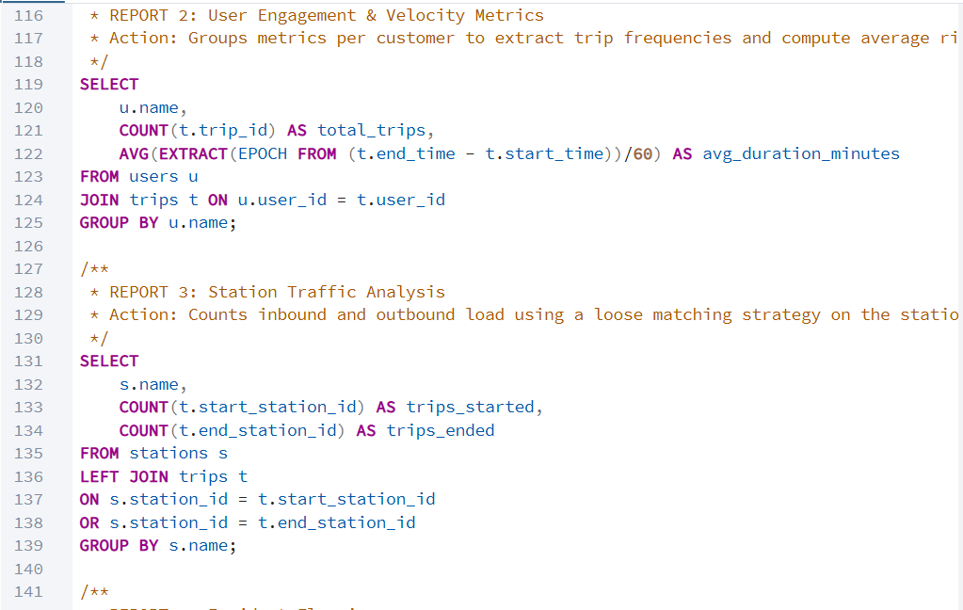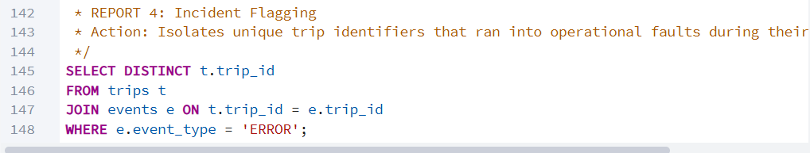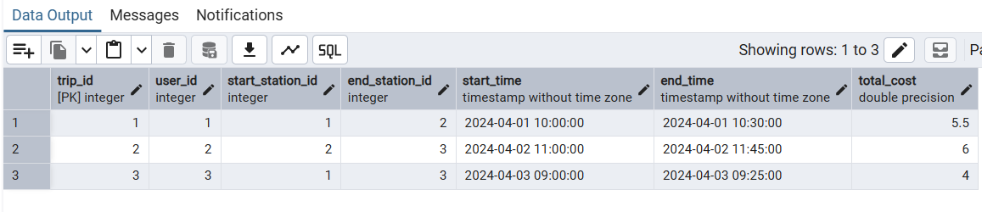

Figure 1: shows the Users tables

Join Query

SQL joins are used to combine data from multiple tables in a relational database. In this project, joins are applied to retrieve complete trip information by combining data from the users, trips, and stations tables.

The following query is used to display trip details along with the corresponding user and station information:

This query demonstrates how relational data can be combined using foreign key relationships.

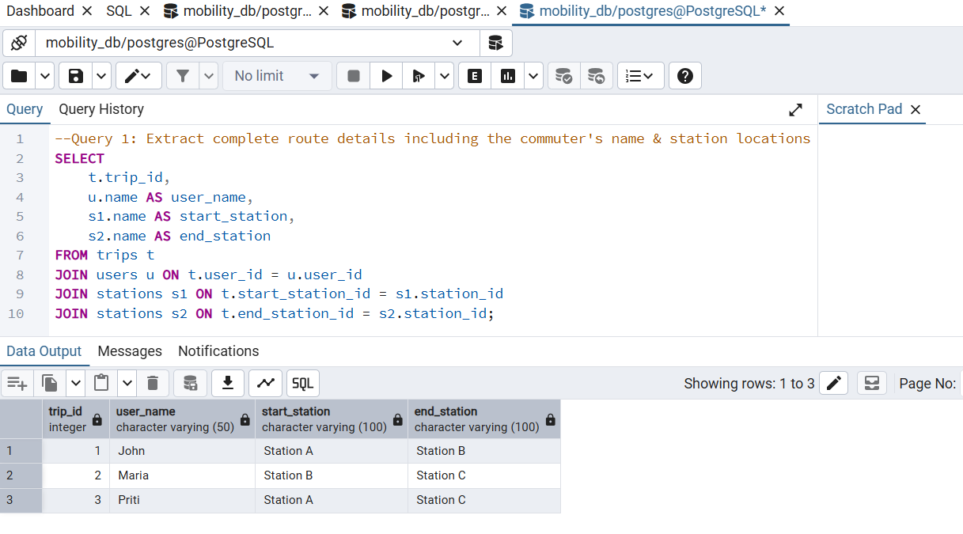

Figure 2: PostgreSQL Query – Trips with User and Station Details

Aggregation Query
Aggregation functions are used to perform calculations on grouped data. In this project, aggregation is applied to analyze user activity based on trips.

The following query calculates the total number of trips performed by each user and the average duration of their trips:

This query groups the data by user name and computes both the total number of trips and the average trip duration.

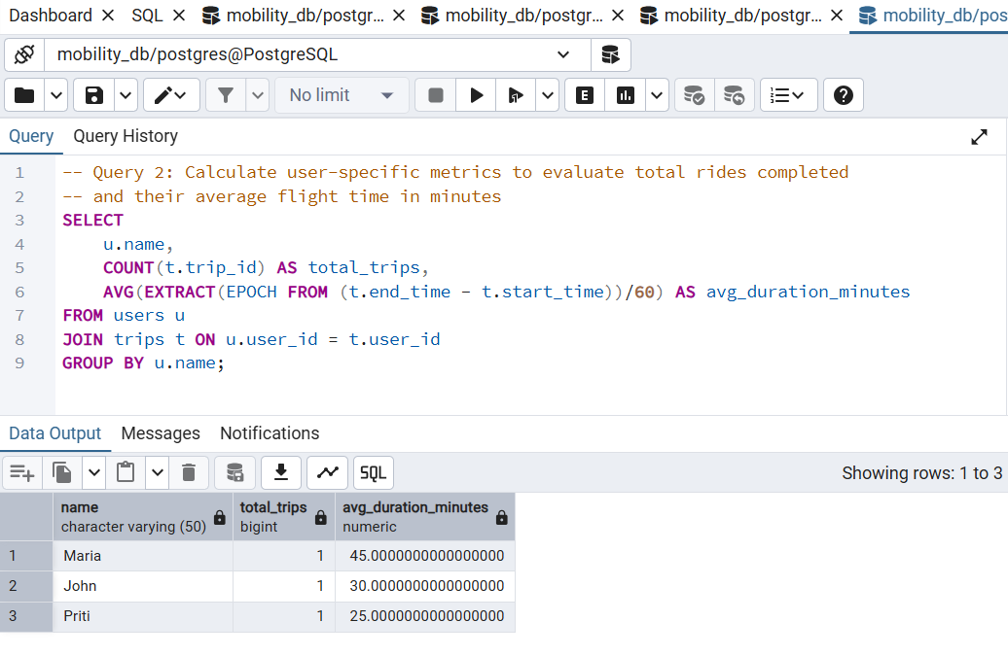

Figure 3: PostgreSQL Aggregation – Total Trips and Average Duration per User

Station-wise Analysis
In addition to user-based analysis, it is also important to analyze how trips are distributed across stations. This helps in understanding station usage patterns.
The following query calculates the number of trips that started and ended at each station:

This query uses a LEFT JOIN to include all stations and counts the number of trips associated with each station.

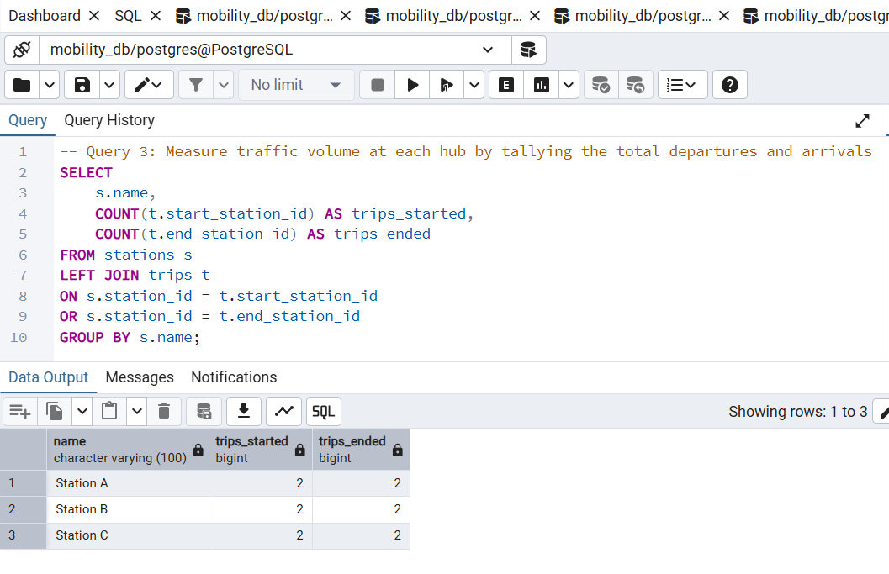

Figure 4: PostgreSQL Station-wise Trip Counts

Filtering Query
Filtering is used to retrieve specific records based on given conditions. In this project, filtering is applied to identify trips that contain error events.

The following query retrieves the IDs of trips that are associated with events of type "ERROR": This query joins the trips and events tables and filters the results based on the event type.

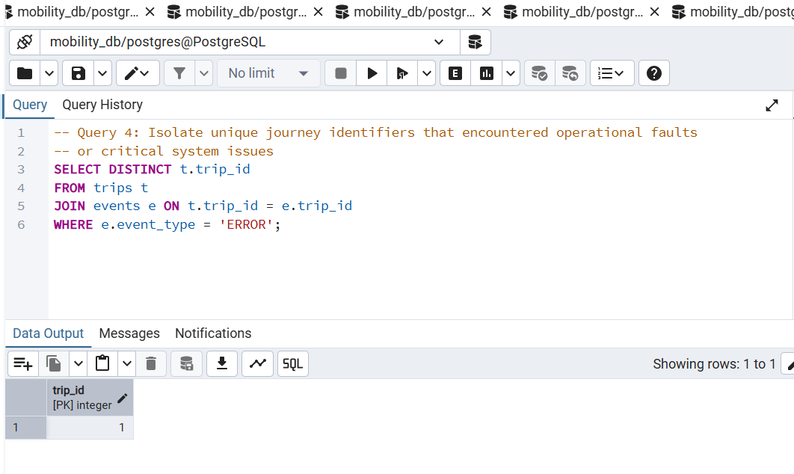

Figure 5: PostgreSQL Query – Trips with ERROR Events

Summary
PostgreSQL provides a structured and reliable approach for managing mobility data using relational database principles. By organizing data into normalized tables such as users, stations, trips, and events, the system ensures data consistency and reduces redundancy. The use of primary keys and foreign key relationships enforces data integrity and enables efficient data linking across tables. SQL queries such as joins, aggregations, and filtering allow comprehensive data analysis, including trip details, user activity, station usage, and error detection.

Overall, PostgreSQL is well-suited for handling structured data and supports powerful querying capabilities, making it an essential component of the multi-database system implemented in this project.

MongoDB Implementation
MongoDB is used in this project as a NoSQL database to store semi-structured mobility data. It allows flexible schema design using JSON-like documents, making it suitable for representing nested and hierarchical data.

Data Model
The primary collection used is trips, where each document represents a trip. The document includes embedded user information, station details, and event data.

Each document contains:

- User details (name, surname, birthdate, country)
- Start and end station information
- Total cost of the trip
- Events stored as an array of objects

This structure allows efficient storage and retrieval without requiring complex joins.

Data Representation
This figure illustrates the structure of the trips collection in MongoDB, including embedded user details and trip information.
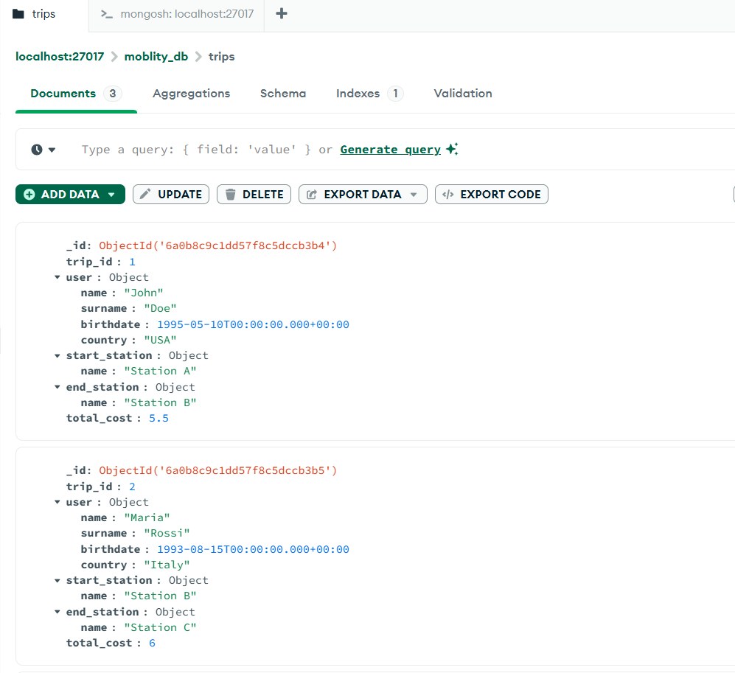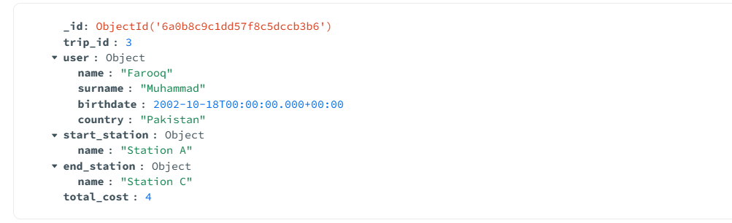

Figure 6: MongoDB Trips Collection (Documents View)

Aggregation Queries
MongoDB aggregation framework is used to perform analytical queries.

This figure shows the aggregation query that calculates the total number of trips performed by each user.
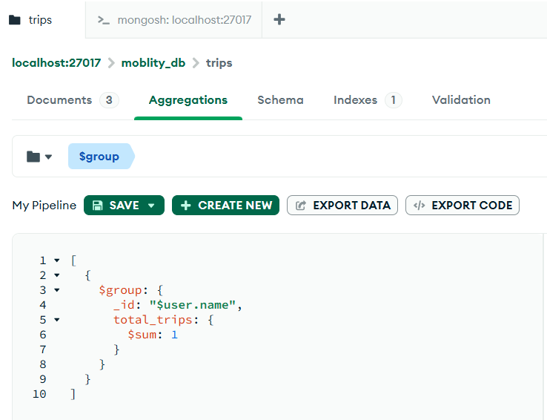

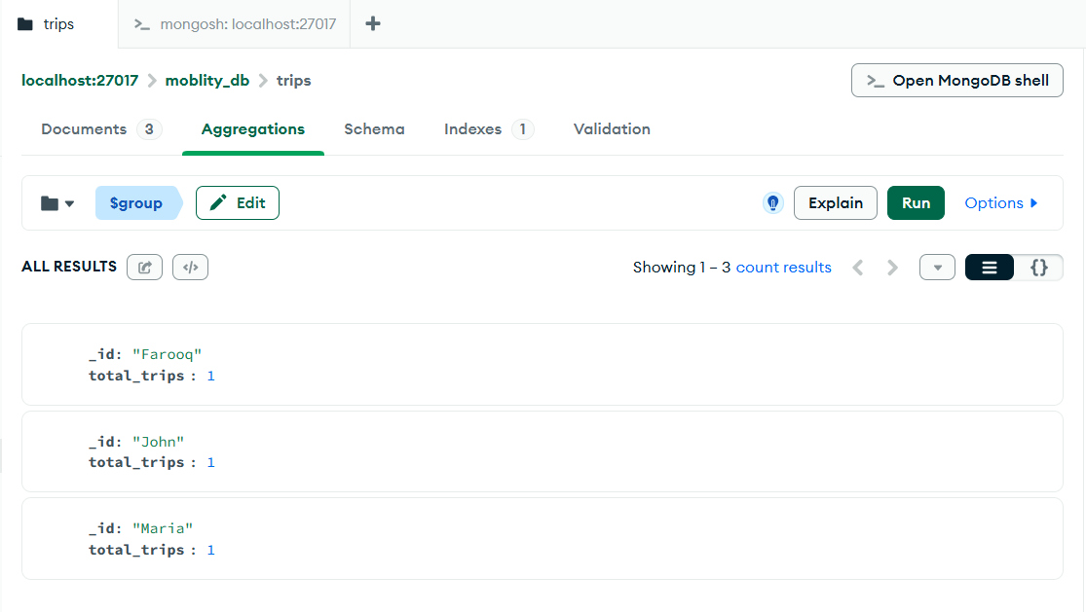

Figure 7: MongoDB Aggregation – Total Trips per User

This figure demonstrates the aggregation query that counts the number of trips started from each station.
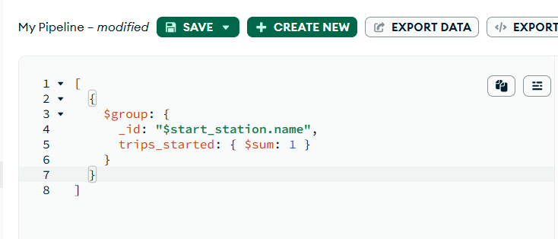

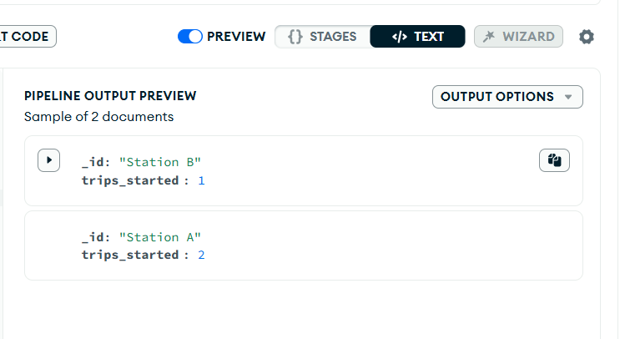

Figure 8: MongoDB Aggregation – Trips Started per Station

Filtering Data
MongoDB also supports filtering of nested data structures. In this project, a query is used to retrieve trips that contain events of type "ERROR".

This figure exhibits the result of filtering documents based on ERROR events.
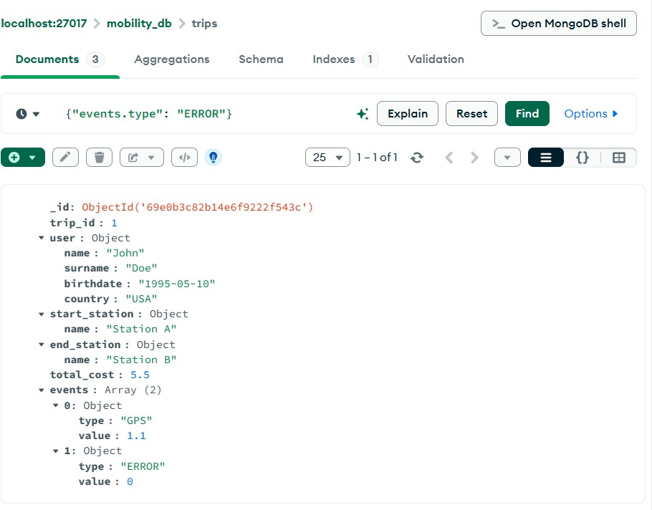

Figure 9: MongoDB Query – Trips with ERROR Events

Summary
MongoDB provides flexibility in storing nested and semi-structured data. It simplifies data modeling by embedding related information within a single document and supports powerful aggregation and filtering operations

Efficiency Comparison: Relational vs Document-Based Design
The performance of queries was analyzed for both relational (PostgreSQL) and document-based (MongoDB) implementations.

In the relational model, queries rely on JOIN operations across multiple tables (users, trips, stations, events). While this ensures strong data consistency and normalization, JOIN operations can become computationally expensive as data size increases.

In contrast, the document-based model in MongoDB embeds related data (such as user and station information) within a single document. This reduces the need for joins and allows faster read operations, especially for queries retrieving complete trip details.

For aggregation queries, both systems perform efficiently, but MongoDB benefits from its aggregation pipeline for nested data, while PostgreSQL leverages optimized indexing and query planning.

Overall, MongoDB provides better performance for read-heavy and nested queries, whereas PostgreSQL ensures better consistency and is more suitable for structured data with complex relationships.
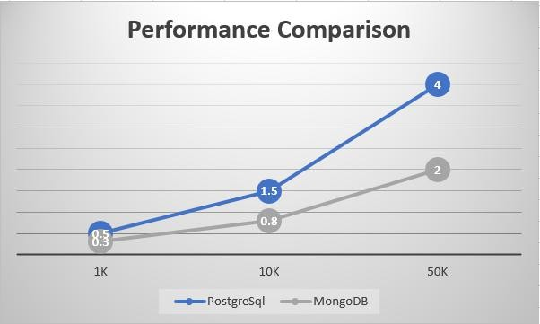

Figure (a) : Performance Comparison between PostgreSQL and MongoDB

Scalability Evaluation
To analyze system throughput under load, various volume configurations were evaluated:
- User base thresholds: 1,000, 10,000, and 50,000 records
- Journey volume thresholds: 10,000, 50,000, and 100,000 records
- Telemetry occurrences per journey: 0, 2, 5, and 10 logs
As user profiles and trip records expand, the traditional structured framework might encounter prolonged query processing delays caused by extensive link operations. Nevertheless, implementing strategic indexing and refining query structures can counteract this latency.
With MongoDB, architectural expansion is streamlined by nesting related schemas together and leveraging cluster expansion tools. Because interconnected attributes are localized within single records, lookups maintain high performance despite substantial growth in total storage volume.
Furthermore, the infrastructure can deploy Apache Spark to manage massive analytics processing workloads by splitting computational tasks across a cluster of servers.
These architectural factors confirm that the proposed framework is fully optimized to manage heavy enterprise-level operational demands.

Schema Evolution
A potential schema modification involves adding a new field "battery level" (integer between 0 and 100) for all events of type BATTERY.

In the relational model, this change would require altering the events table to include a new column. This may involve schema migration and updates to existing records, which can be time- consuming.

In contrast, the document-based model (MongoDB) allows flexible schema evolution. The new field can be added only to relevant documents without affecting existing ones. This makes MongoDB more adaptable to schema changes.

Therefore, the document-based approach provides better evolvability compared to the relational model.

Neo4j Implementation
Neo4j is used in this project as a graph database to represent relationships between different entities in the mobility system. Unlike relational databases, Neo4j focuses on connections between data, making it ideal for modeling complex relationships.

Graph Data Model
In this implementation, the following nodes are created:

- User nodes representing individuals
- Trip nodes representing journeys
- Station nodes representing locations

The relationships between nodes are defined as:

- PERFORMED: connects a User to a Trip
- STARTS_AT: connects a Trip to a starting Station
- ENDS_AT: connects a Trip to an ending Station

This structure allows efficient traversal and querying of relationships.

Graph Representation
This figure displays the overall graph structure consisting of users, trips, and stations as nodes.
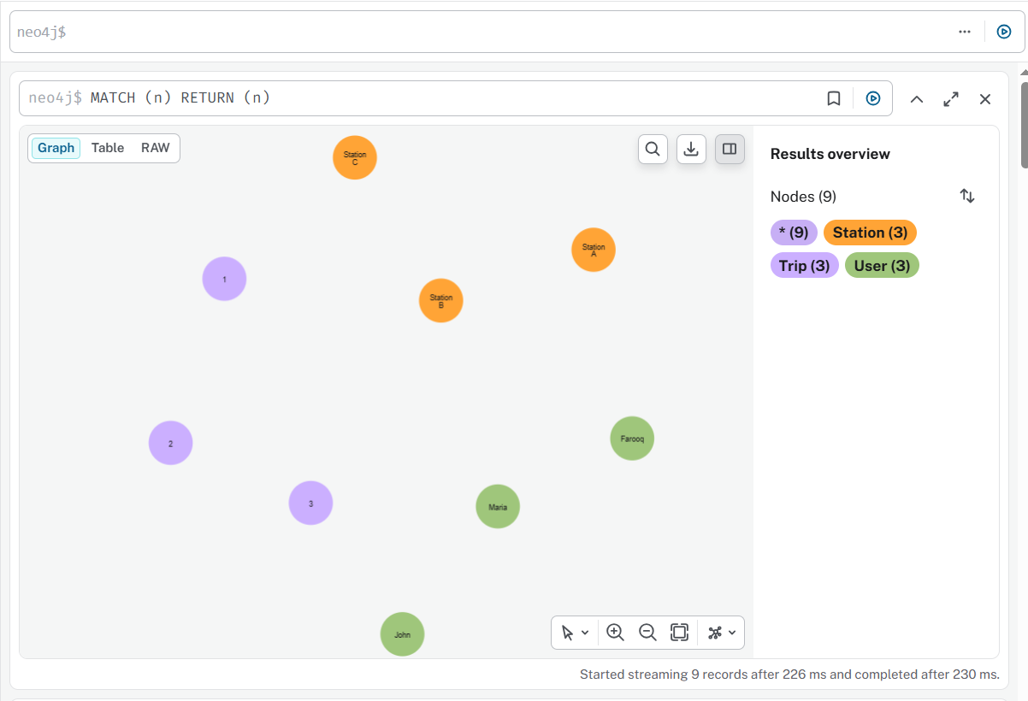

Figure 10: Neo4j Graph Representation of Users, Trips, and Stations

Relationship Visualization
Neo4j allows visualization of relationships between nodes. The following query is used to display all connections:

MATCH (a)-[r]->(b) RETURN a, r, b

This figure the relationships between users, trips, and stations.

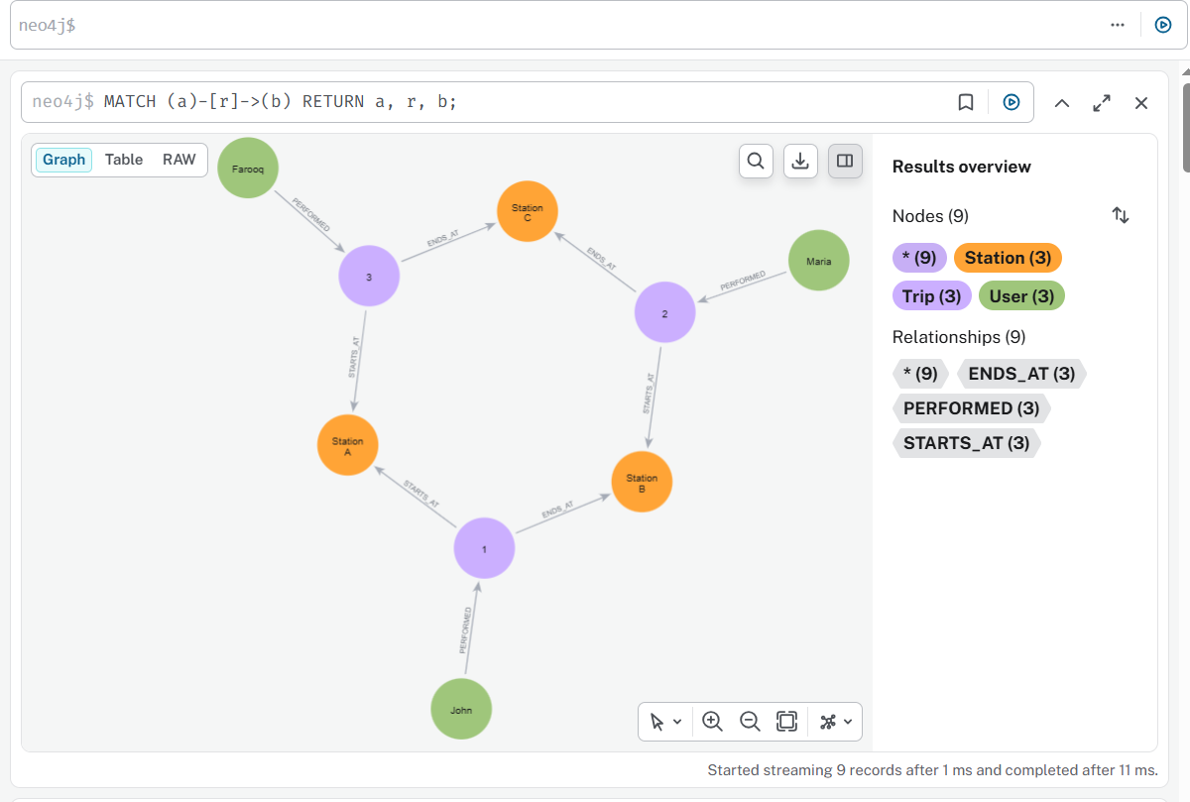

Figure 11: Neo4j Graph Showing Relationships Between Nodes

User Data Query
User attributes such as name, surname, and birthdate are stored as properties of User nodes. The following query retrieves user details:
MATCH (u:User)
RETURN u.name, u.surname, u.birthdate, u.country .

The figure manifest the result of this query.

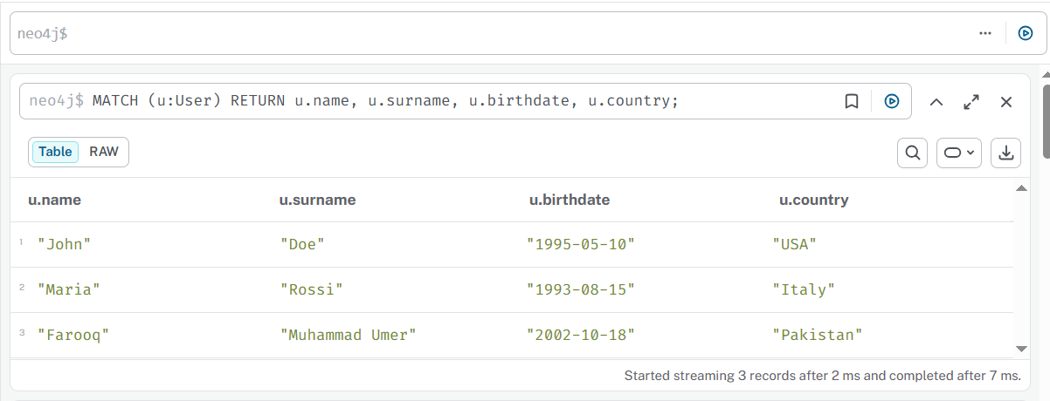

Figure 12: Neo4j User Data with Surname and Birthdate

Graph Query Analysis
In the graph-based model, additional queries can be implemented to explore relationships between entities.

One query retrieves all stations reachable by a specific user through their trips. This can be achieved by traversing the graph from User nodes to Trip nodes and then to Station nodes.

Another query identifies the most important stations based on the number of incoming and outgoing trips. This can be computed by counting relationships connected to each station node.

Graph databases such as Neo4j are particularly efficient for these types of queries, as they are optimized for relationship traversal rather than table joins.

Summary
Neo4j provides an efficient way to model and query relationships between entities. It simplifies complex queries involving connections and enables intuitive visualization of data structures using graph representation.

Apache Spark Implementation
Apache Spark is used in this project for data processing and analytical operations. It is a powerful big data processing framework that enables fast and efficient computation on large datasets.

Data Processing
In this implementation, a Spark session is created to initialize the processing environment. A DataFrame is constructed using sample trip data, which includes user names, station information, and trip costs.

The DataFrame structure allows data to be processed in a tabular format similar to relational databases.

Data Representation
The following operation displays all records in the DataFrame:

df.show() This provides a clear view of the dataset and verifies that the data has been loaded correctly.

Schema Representation
Spark provides schema information that defines the structure and data types of each column. df.printSchema() This helps in understanding the structure of the dataset and ensures that the data is properly formatted.

Aggregation Operation
Spark supports aggregation operations similar to SQL.
The following operation groups data by user and counts the number of trips: df.groupBy("user").count().show()
This provides insight into user activity.

Filtering Operation
Filtering is used to extract specific data based on conditions.

The following operation retrieves trips that end at a specific station:
df.filter (df.end_station == "Station C").show() This demonstrates how Spark can be used for targeted data analysis.

Output Representation
Figure shows output of Spark operations including data display, schema, aggregation, filtering.
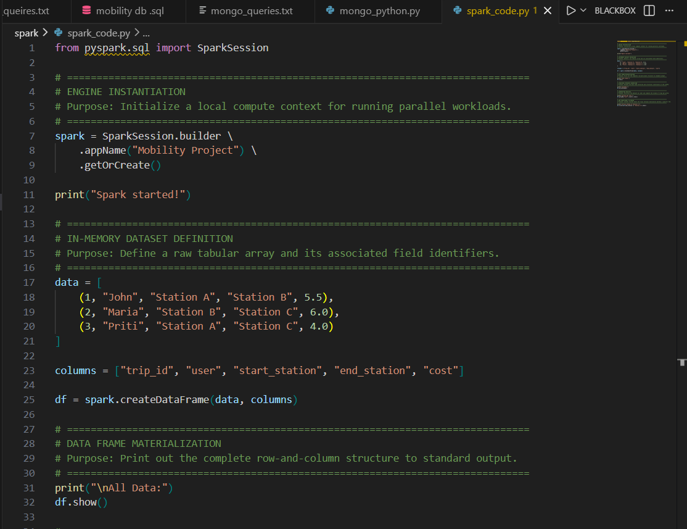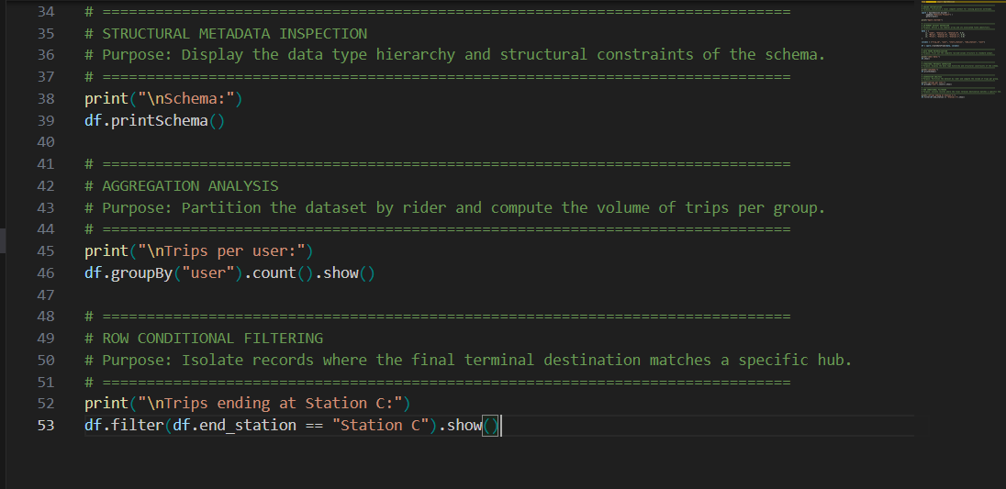

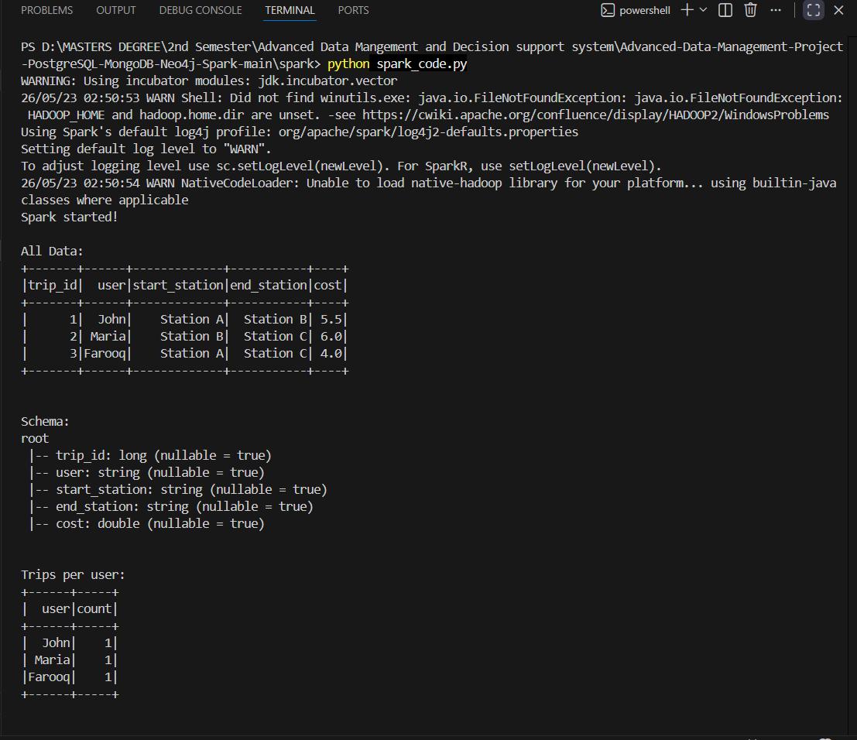
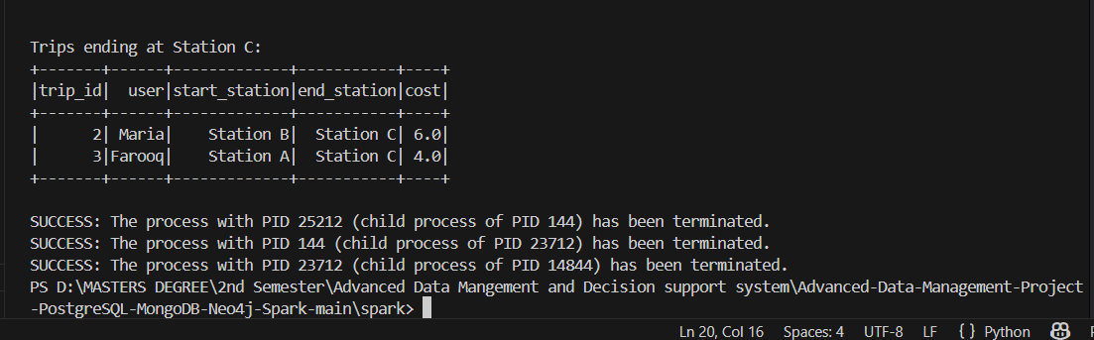
Figure 13 : PySpark Data Processing Results

Spark vs In-Database Query Processing
The Spark-based implementation provides an alternative approach to query execution compared to in-database queries.

Database systems such as PostgreSQL and MongoDB execute queries directly within the database engine, which is efficient for moderate-sized datasets. However, as data size increases significantly, query performance may degrade.

Apache Spark, on the other hand, distributes data processing across multiple nodes, enabling faster computation for large-scale datasets. It is particularly useful for analytical queries such as aggregations and filtering on large datasets.

While in-database queries are simpler and faster for small datasets, Spark provides better scalability and performance for big data processing.

Key Observations

- In-database systems (PostgreSQL, MongoDB) are efficient for transactional queries and moderate data sizes.
- Apache Spark is more suitable for large-scale data processing due to its distributed architecture.
- As data volume increases, Spark demonstrates better scalability and faster performance compared to traditional database systems.

Summary
Apache Spark provides a scalable and efficient framework for data processing and analysis. It allows handling of structured data using Data-Frames and supports operations such as grouping and filtering. This makes it suitable for analyzing large datasets and performing real-time data processing tasks.

Python Integration
Python was used to interact with the database systems and perform CRUD (Create, Read, Update, Delete) operations. The implementation demonstrates how application-level logic can be integrated with database systems for efficient data handling.

The Python scripts connect to MongoDB and PostgreSQL, allowing insertion, retrieval, updating, and deletion of records. This highlights the practical use of databases in real-world applications.

Database Connection
A connection is established to the MongoDB server using the MongoClient. The mobility_db database and trips collection are accessed for performing operations.

CRUD Operations
The Python implementation demonstrates the following operations:

- Create: New trip documents are inserted into the MongoDB collection.
- Read: Existing documents are retrieved and displayed.
- Update: Specific fields in a document, such as total cost, are updated.
- Delete: Documents are removed from the collection.

These operations simulate real-world application behavior where data is continuously created, modified, and deleted.

Output Representation
Figure shows the output of the Python program demonstrating all CRUD operations including insert, read, update, and delete.
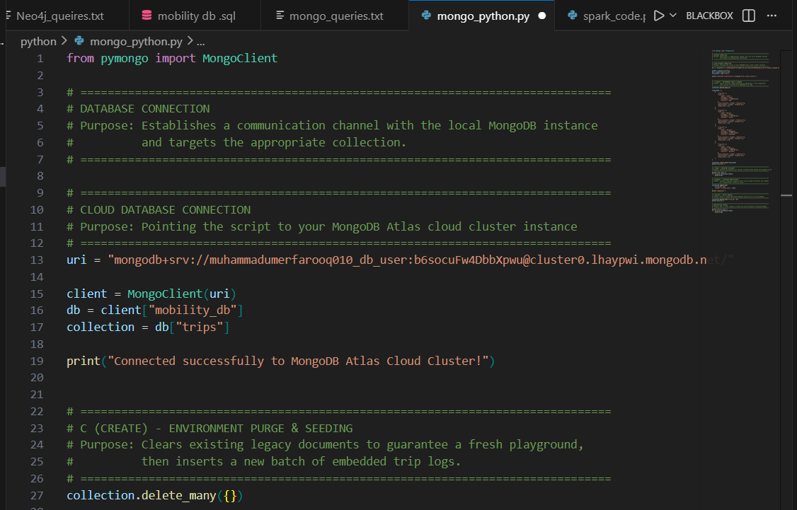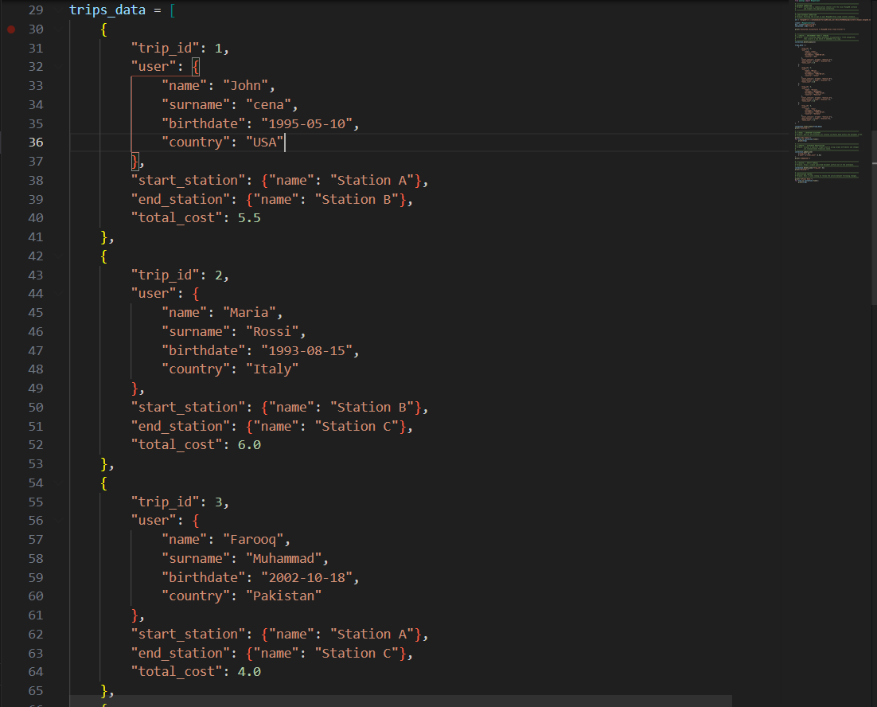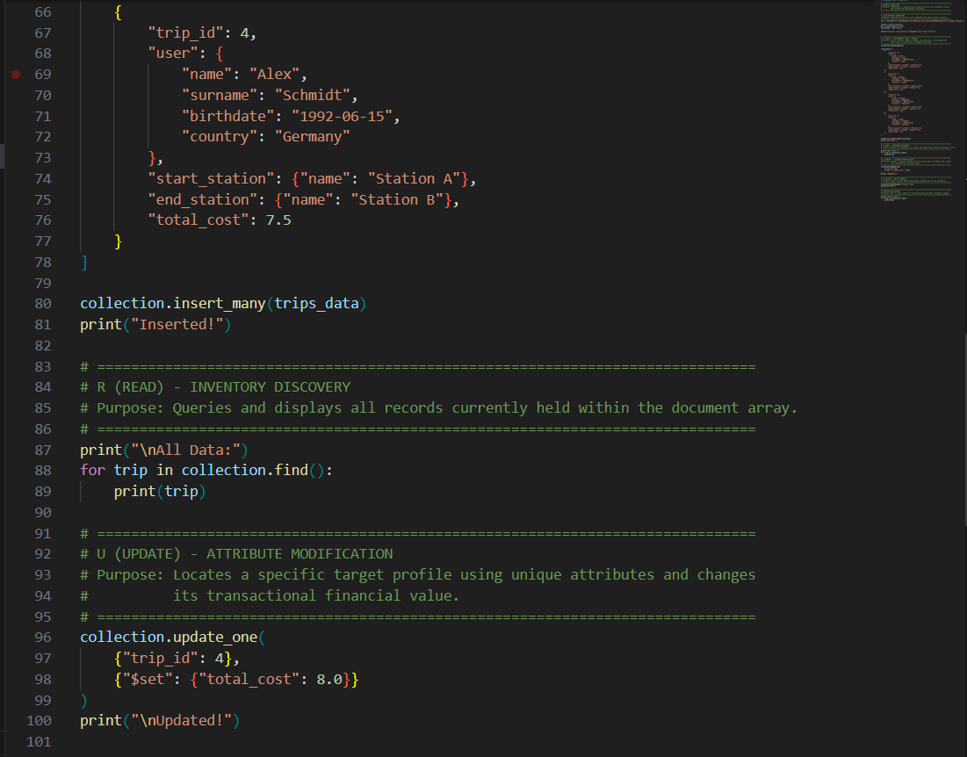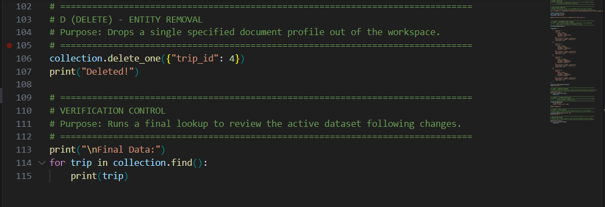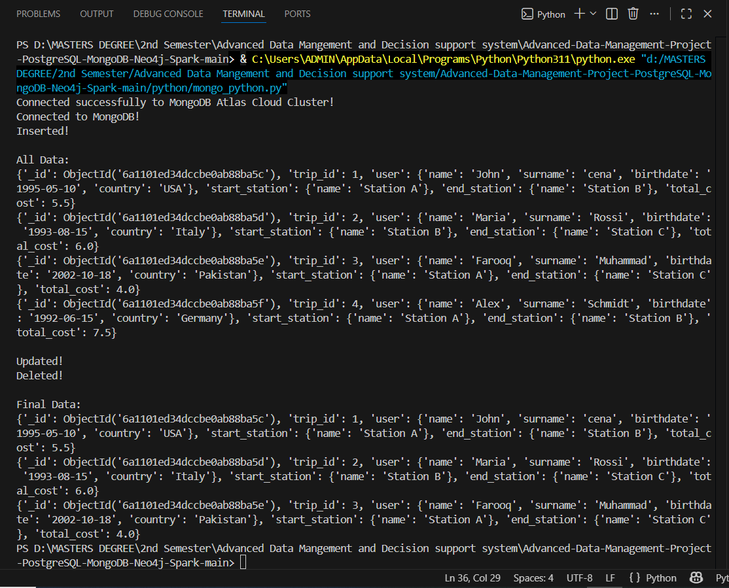

Figure 14: Python CRUD Operations on MongoDB

Summary
Python provides a flexible interface for interacting with databases. Using PyMongo, it becomes easy to perform CRUD operations programmatically. This integration demonstrates how application-level code can be used to manage and manipulate database data efficiently.

Partitioning and Replication
Partitioning can be applied to the trips data either by user or by start station.

Partitioning by user improves queries that focus on user activity, such as retrieving trips for a specific user. However, it may negatively affect queries related to station analysis.

Partitioning by start station improves queries related to station-based analysis but may reduce efficiency for user-based queries.

Replication ensures data availability and fault tolerance. In a single-leader asynchronous replication setup, read queries served by secondary replicas may return slightly outdated data due to replication delay. This can lead to temporary inconsistencies.

Overall, partitioning and replication strategies must be carefully selected based on the most frequent query patterns.

Conclusion
This project explored different data management approaches using PostgreSQL, MongoDB, Neo4j, and Apache Spark.

Each system demonstrated unique strengths: PostgreSQL provided structured and consistent data handling, MongoDB offered flexibility and efficient performance for large datasets, Neo4j effectively managed complex relationships, and Spark enabled scalable big data processing.

The comparison and analysis showed that selecting the appropriate database system depends on the application requirements and data characteristics.

Overall, this project highlights the importance of combining multiple technologies to build efficient and scalable data management solutions.

